Juno
Spacecraft Description

By Bill Kurth

2012-06-01

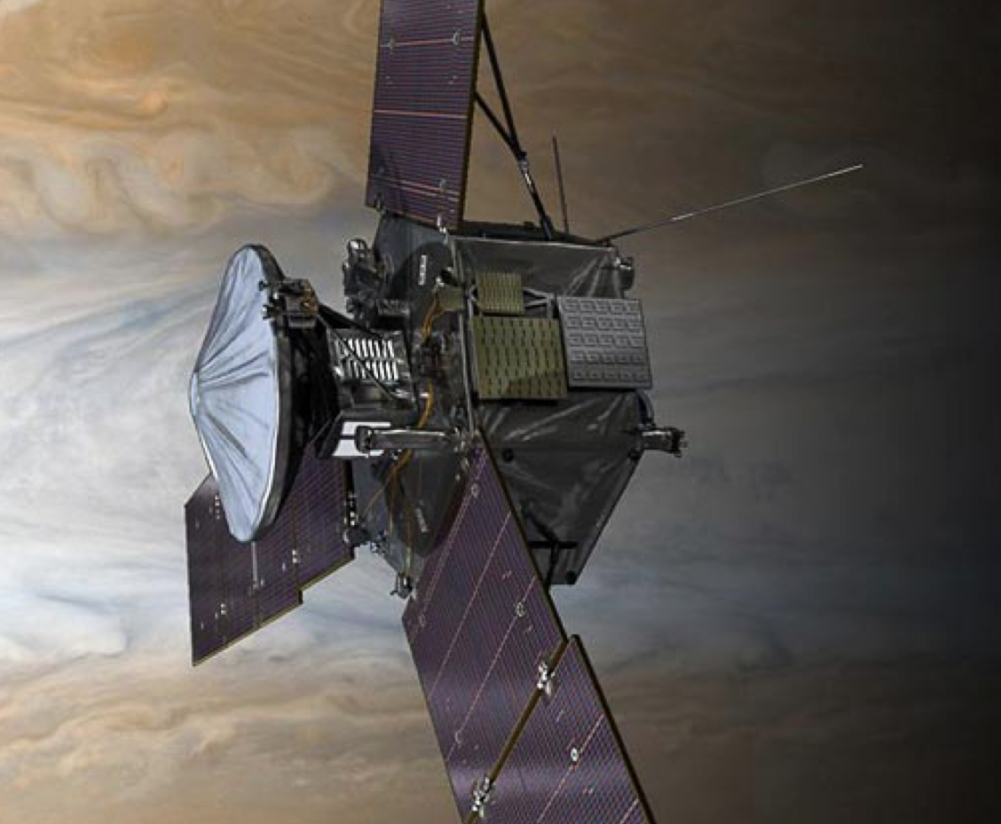

Juno Spacecraft (ID=JNO) Description

The majority of the text in this file was extracted from the Juno Mission Plan Document, S. Stephens, 29 March 2012. [JPL D-35556]

Overview

For most Juno experiments, data were collected by instruments on the spacecraft then relayed via the orbiter telemetry system to stations of the NASA Deep Space Network (DSN). Radio Science required the DSN for its data acquisition on the ground. The following sections provide an overview, first of the orbiter, then the science instruments, and finally the DSN ground system.

Juno launched on 5 August 2011. The spacecraft uses a deltaV-EGA trajectory consisting of a two part deep space maneuver on 30 August and 3 September 2012 followed by an Earth gravity assist on 9 October 2013 at an altitude of 500 km. Jupiter arrival is on 5 July 2016 using a 107-day capture orbit prior to commencing operations for a 1-(Earth) year long prime mission comprising 32 high inclination, high eccentricity orbits of Jupiter. The orbit is polar (90 degree inclination) with a periapsis altitude of 4500 km and a semi-major axis of 19.91 RJ (Jovian radius) giving an orbital period of 10.9725 days. At the beginning of the prime mission, the line of apsides is nearly in the equatorial plane, but precesses throughout the mission such that the apojove moves to southern latitudes. The primary science is acquired for approximately 6 hours centered on each periapsis although fields and particles data are acquired at low rates for the remaining apoapsis portion of each orbit.

Juno is a spin-stabilized spacecraft equipped for 8 diverse science investigations plus a camera included for education and public outreach. The spacecraft includes one high gain (HGA) used as the prime communications antenna and radio science at Jupiter, two low gain antennas (LGAs) and a toroidal medium gain antenna used for some intervals in cruise and during critical activities when the HGA cannot be Earth-pointed, a large set of solar arrays in three 'wings', a main engine, and attitude thrusters. In this description Juno will frequently be called 'the spacecraft.'

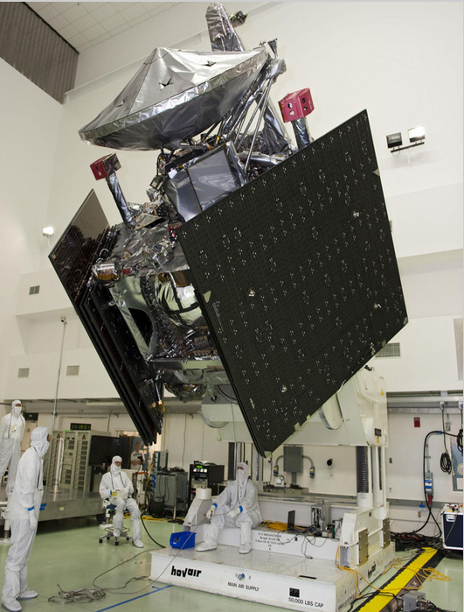

Figure 1. Testing of the Spacecraft. The large black areas are the folded solar cell arrays.

Juno is a spin-stabilized spacecraft with a large spin-to-transverse moment of inertia ratio. It is solar powered with 3 large, deployable rigid-panel wings that can be moved to adjust the spin axis to the HGA boresight. The solar panels are spaced at 120 deg. intervals around a basic 6-sided structure. Juno utilizes high energy density Li ion batteries for battery-regulated bus voltage. Basic radiation protection for sensitive electronics is afforded by a titanium- walled vault. Juno has a dual-mode propulsion system with a deployable micrometeoroid shield for the main engine. Attitude control thrusters are used for re-orienting the spin axis and for smaller trajectory/orbit corrections, and spin-up/down manuevers. The thermal design uses a cold-biased passive design with software- controlled heaters. Attitude control is provided using Inertial Measurement Units, Stellar Reference Units, Spinning Sun Sensors, and active (thrusters) and passive (fluid-filled loop) nutation damping. Telecom is achieved with X-band uplink and downlink coupled with five antennas for complete coverage in various attitudes and tones capability is included for critical low-link margin telemetry. Ka-band telecom is included for improved Doppler measurement performance. Essential systems are redundant and cross-strapped. The z-axis of the spacecraft coordinate system is co-aligned with the HGA axis, hence, nominally points toward Earth. The spacecraft x-axis is in the direction of the solar panel which includes the MAG boom at the end. The y-axis completes a right-hand orthogonal system.

Spacecraft Subsystems

The spacecraft comprises several subsystems, which are described briefly below. For more detailed information, see JPLD-5564.

Structures and Mechanisms Subsystem

The spacecraft structure uses heritage composite panel and clip construction for decks, central cylinder, and gusset panels. Polar mounted off-center spherical tanks are consistent with a spinning spacecraft design with a high, stable inertia ratio. The central cylinder has high torsional stiffness. Six gussets provide stiffness for the solar arrays. Components are located such that they meet all mechanical requirements, including mass, field of view, magnetics, and alignments. The radiation vault uses titanium panels that provide structure as well as shielding. The Telecom subassembly is contained on one panel. Louvers on the outside reject heat during Inner Cruise. The vault also serves as a Faraday cage. Spacecraft mechanisms include solar array articulation, providing up to 4.5 deg. of wing tilt, and allowing approximately 1.9 deg. of principal axis adjustment. A main engine cover must open and close for each of 4 main engine burns as well as main engine flushing burns, and also provides micrometeoroid protection. Solar array wings consist of 11 solar panels and 1 MAG boom. They use heritage designs for (a) spring driven and viscously damped deployment, and (b) a multi-panel retention and release.

Telecom Subsystem

The Gravity Science and Telecom Subsystem provides X-band command uplink and engineering telemetry and science data downlink for the entire post- launch, cruise, and Jupiter orbital operations at Earth ranges up to 6.5 AU. The subsystem also provides for dual-band (X- and Ka-band) Doppler tracking for Gravity Science at Jupiter (concurrent X-band telemetry during Gravity Science passes also contributes to data return requirements). The subsystem is designed, built, and tested at JPL prior to delivery to Lockheed Martin. The non-science part of the subsystem is fully redundant. The Ka-band uplink for Gravity Science is single-string as is the Ka-band power amplifier. The subsystem is designed to provide a minimum 2-sigma margin on all links. Juno will normally use NASA's Deep Space Network (DSN) 34-m subnet for communications. The 70-m subnet will be used for critical event coverage post launch, reception of tones during main engine maneuvers (DSMs, JOI, and PRM), enhanced data return during selected orbits at Jupiter, and for safe mode telecom.

The telecom design is sized to provide a minimum science downlink rate of 18kbps into a 34-m DSN station at max range (6.46 AU) during orbital operations, and 12 kbps during Gravity Science perijove passes. Higher data rates will be used at shorter ranges or with a 70-m DSN station. The design also supports sending tone modulation during DSMs, JOI, and PRM burns when the spacecraft spin axis is nearly normal to the Earth line.

Telecom equipment includes two Small Deep Space Transponders (SDSTs), both with X/X and one with additional X/Ka capability. The X/X/Ka capability serves as a partial backup for Gravity Science. There are two 25-W X-band Traveling Wave Tube Amplifiers (TWTAs), 5 Waveguide Transfer Switches (WTSes), 2 X-band diplexers, filters, microwave components, waveguide, and cabling. These are all used to feed 5 separate antennas. The high-gain antenna (HGA) is a 2.5-m, shaped, axially symmetric, Gregorian, dual-reflector antenna fed by a dual-band, coaxial, corrugated feed. The HGA supports uplink and downlink at both X and (carrier-only) Ka-band. There is an X-band medium-gain antenna (MGA or F-MGA), forward and aft low-gain antennas (LGAs, specifically F-LGA and A-LGA), and toroidal antenna (T-LGA) that provides coverage during the DSMs, JOI, and PRM burns. The toroidal antenna is also used briefly during cruise when the Sun-Probe-Earth (SPE) angle is near 90 deg.

All antennas except the toroidal antenna are aligned with the spacecraft Z axis, which will be aligned with the spin axis shortly after launch using the adjustable solar array wing actuators. The HGA, MGA, and forward LGA are nearly co-boresighted (the MGA and LGAs are slightly offset from the spin vector). The aft LGA is used when the spacecraft's trajectory goes inside of the Earth's orbit and the SPE angle is greater than 110 deg.

The Ka-band Translator Subsystem (KaTS) receives a Ka-band uplink through the HGA from the DSN (DSS-25) and coherently generates a Ka-band downlink carrier signal and then amplifies the signal. The signal is then guided to the Ka-band feed of the HGA for the Gravity Science two-way Ka-band Doppler signal. The KaTS is provided by the Italian Space Agency.

Propulsion Subsystem

Juno uses a dual-mode Propulsion Subsystem, with a biprop main engine (ME) and monoprop Reaction Control System (RCS) thrusters. The 12 thrusters are mounted on 4 Rocket Engine Modules (REMs), allow translation and rotation about 3 axes, and provide some redundancy. There are 8 lateral thrusters, canted away from X by 5 deg. along Y and by 12.5 deg. along Z, and 4 axial thrusters, canted away from Z by 10 deg. along Y. 6 equal-sized spherical propellant tanks contain fuel (4 tanks) and oxidizer (2). Biprop mode (N2O4/hydrazine) is used for major maneuvers and flushing burns, and monoprop mode (blowdown hydrazine) is used for spin-up and -down, precession, active nutation damping, and most TCMs and OTMs. The Leros-1b main engine is well-characterized, and is fixed on the Z axis, pointing aft. Isolation valve ladders included in the pressurization system eliminate propellant mixing concerns. RCS thrusters are located to minimize plume interactions. The propellant tanks are sized consistent with the planned delta-V budget, for the maximum spacecraft mass that can be lifted by an Atlas V 551 with the required characteristic energy for the mission.

Electrical Power Subsystem (EPS)

Juno's redundant, single fault tolerant Electrical Power Subsystem manages the spacecraft power bus and distribution of power to payloads, propulsion, heaters, mechanism motor actuators, NASA Standard Initiators (NSIs), and avionics. The Power Distribution and Drive Unit (PDDU) monitors and manages the spacecraft power bus, manages the available solar array power to meet the spacecraft load and battery state of charge (SOC), and provides controlled power distribution. The Pyro Initiator Unit (PIU) includes a redundant, dual fault tolerant Pyrotechnic Initiator Module (PIM). Power generation is provided by 3 solar arrays using current generation Ultra Triple Junction (UTJ) solar cells. Two 55 A-hr Li ion batteries provide power when Juno is off-Sun or in eclipse, and are tolerant of the Jupiter radiation environment. The power modes during Science Orbits are sized for either an MWR or a GRAV orbit, and provide sufficient margin given the expected loads during perijove science passes as well as DSN telecom passes. Sufficient power and energy margins have also been demonstrated for the Launch, DSMs, JOI, PRM, and deorbit burn mission events, as well as safe mode near EOM.

Command and Data Handling Subsystem (C&DH)

The C&DH is based on two redundant, single fault tolerant boxes developed for
MRO. Each C&DH box includes a cPCI bus interconnected to 3U cards (except the
DTCI card which uses 6U format) and a RAD750 flight processor with 256 Mbytes
of NVM flash memory and 128 MBytes of SFC DRAM local memory. It provides 100
Mbps total instrument throughput, more than enough for payload requirements.
32 Gbits (base 2, EOL) of science data storage (plus 8 Gbits for EDAC) are
available on the DTCI card, which has been demonstrated to be sufficient for
minimum and maximum science orbit downlink data requirements, and representative stress cases that account for data retransmission and prioritization.

Guidance, Navigation, and Control Subsystem (GN&C)

The Juno GN&C Subsystem uses spin-stabilized control. The launch spin rate of
1.4 RPM is initiated by the launch vehicle upper stage (and adjusted by the spacecraft after solar array deployment). The planned spin rate varies during the mission: 1 RPM for cruise, 2 RPM for science operations, and 5 RPM for main engine maneuvers. MWR and GRAV orbits at Jupiter use 2 different spacecraft attitudes: spin axis normal to the orbit plane for MWR orbits, and HGA Earth-pointed for GRAV orbits. Precession and spin control use balanced mode for minimum delta-V, and are capable of unbalanced mode for lower fuel use (although not planned to be used). Active nutation damping requires the Inertial Measurement Units (IMUs). Delta-V maneuvers using the RCS thrusters can be either turn-burn-turn (TBT), which requires precession to turn to the desired attitude, or vector-mode (Vect), in which thrust is provided in both axial and lateral directions. Main engine maneuvers require precession to point the engine in the desired direction. One of two Stellar Reference Units (SRUs) and one of two Spinning Sun Sensors (SSSes) are continuously powered (the SRU is turned off for ME burns, and both SSSes are powered on during safe mode). One of two IMUs is powered for delta-V maneuvers, large precessions (larger than ~2.5 deg.), active nutation damping, and spin control.

Temperature Control Subsystem (TCS)

Juno's Thermal Control Subsystem uses a passive cold biased design with heaters and louvers. The core TCS consists of an insulated, louvered electronics vault atop an insulated, heated propulsion module. This design accommodates all mission thermal environments from perihelion to orbital operations. During cruise, while the spacecraft is close to the Sun, the HGA is used as a heat shield to protect the vault avionics. Outside ~1.4 AU, the spacecraft pointing is unrestricted, while inside ~1.4 AU Sun-pointing is generally required and required off-Sun-pointing for maneuvers is controlled for thermal reasons. Most instrument electronics are contained within the radiation vault and are thermally managed as part of the vault TCS. Science sensors are externally mounted to the deck and are individually blanketed and heated to maintain individual temperature limits.

Juno Science Instruments

Juno's instrument complement includes Gravity Science using the X and Ka bands
to determine the structure of Jupiter's interior; magnetometer investigation (MAG) to study the magnetic dynamo and interior of Jupiter as well as to explore the polar magnetosphere; and a microwave radiometer (MWR) experiment covering 6 wavelengths between 1.3 and 50 cm to perform deep atmospheric sounding and composition measurements. The instrument complement also includes a suite of fields and particle instruments to study the polar magnetosphere and Jupiter's aurora. This suite includes an energetic particle detector (JEDI), a Jovian auroral (plasma) distributions experiment (JADE), a radio and plasma wave instrument (Waves), an ultraviolet spectrometer (UVS), and an Jupiter infrared auroral mapping instrument (JIRAM). The JunoCam is a camera included for education and public outreach. While this is not a science instrument, we plan to capture the data and archive them in the PDS along with the other mission data. The MAG investigation consists of redundant flux gate magnetometers (FGM) and co-located advanced stellar compasses (ASC). The ASCs are provided by the Danish Technical University under an effort led by John Jorgenson.

Scott Bolton is the Juno Principal Investigator. The Science Team members responsible for the delivery and operation of the instruments are listed below:

Instrument Acronym Lead Co-I
Gravity Science GRAV Folkner
Magnetometer MAG Connerney
Microwave Radiometer MWR Janssen
Jupiter Energetic Particle Detector Instrument JEDI Mauk
Jovian Auroral Distributions Experiment JADE McComas
Radio and plasma wave instrument WAVES Kurth
Ultraviolet Imaging Spectrograph UVS Gladstone
Jovian Infrared Auroral Mapper JIRAM Coradini*
Juno color, visible-light camera JUNOCAM Hansen

*deceased

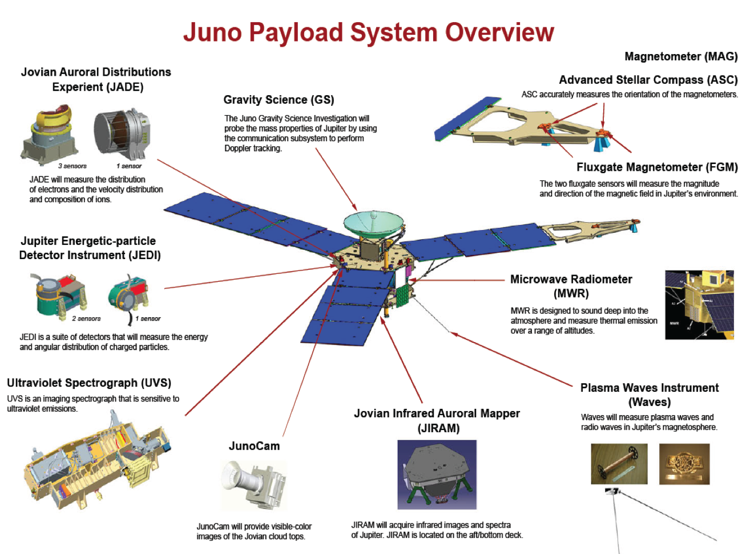
Figure 1. A Schematic of the locations of Juno Instruments

Goals of the Instrument Teams

Gravity Science (GRAV): The Gravity Science investigation was designed to map Jupiter's gravitational field and to determine normalized gravity coefficients J4, J6, and J8 - J14.

Magnetometer (MAG): The Magnetometer investigation was designed to map Jupiter's magnetic field and to derive a spherical harmonic model of Jupiter's main magnetic field through degree and order 14

Microwave Radiometer (MWR): The Microwave Radiometer was designed to characterize Jupiter's atmosphere and to determine the global O/H ratio (water abundance) in Jupiter's atmosphere. To measure latitudinal variations in Jupiter's deep atmosphere (composition, temperature, cloud opacity, and dynamics) and to Measure the microwave brightness temperatures of Jupiter over all latitudes at wavelengths that fully sample the atmospheric thermal emission at all altitude levels from the ammonia cloud-forming region to below the water cloud-forming region

Jupiter Energetic Particle Detector Instrument (JEDI): The Jupiter Energetic Particle Detector Instrument was designed to characterize Jupiter's polar magnetosphere and measure the pitch angle and energy distribution of electrons across auroral features

Jovian Auroral Distributions Experiment (JADE): The Jovian Auroral Distributions Experiment was designed to characterize Jupiter's polar magnetosphere and measure three dimensional time variable, pitch angle, energy and composition distribution of ions and measure ion composition to differentiate between H+, H2+, H3+, O+, and S+.

Radio and Plasma Wave Instrument (Waves): The Waves instrument was designed to characterize Jupiter's polar magnetosphere and measure radio and plasma wave emissions associated with auroral phenomena in the polar magnetosphere

Ultraviolet Imaging Spectrograph (UVS): The Ultraviolet Imaging Spectrograph was designed to characterize Jupiter's polar magnetosphere and characterize the UV auroral emissions

Jovian Infrared Auroral Mapper (JIRAM): The Jovian Infrared Auroral Mapper was designed to characterize Jupiter's atmosphere.

Juno color, visible-light camera (JUNOCAM): The Juno color, visible-light camera was designed to engage the public and educate students.

The Deep Space Network

Radio Science investigations utilize instrumentation with elements both on the spacecraft and at the NASA Deep Space Network (DSN). Much of this was shared equipment, being used for routine telecommunications as well as for Radio Science.

The Deep Space Network is a telecommunications facility managed by the Jet Propulsion Laboratory of the California Institute of Technology for the U.S.
National Aeronautics and Space Administration. The primary function of the DSN is to provide two-way communications between the Earth and spacecraft exploring the solar system. To carry out this function the DSN is equipped with high-power transmitters, low-noise amplifiers and receivers, and appropriate monitoring and control systems.

The DSN consists of three complexes situated at approximately equally spaced longitudinal intervals around the globe at Goldstone (near Barstow, California), Robledo (near Madrid, Spain), and Tidbinbilla (near Canberra, Australia). Two of the complexes are located in the northern hemisphere while the third is in the southern hemisphere.

The network comprises four subnets, each of which includes one antenna at each complex. The four subnets are defined according to the properties of their respective antennas: 70-m diameter, standard 34-m diameter, high-efficiency 34-m diameter, and 26-m diameter. These DSN complexes, in conjunction with telecommunications subsystems onboard planetary spacecraft, constitutes the major elements of instrumentation for radio science investigations. For more information see Asmar and Renezetti, 1993.

References

Asmar, S. W., N. A. Renzetti, The Deep Space Network as an instrument for radio science research, NASA Technical Reports Server, 3STIN...9521456A, 1993."

Stephens, S. K., Juno Project Mission Plan, Rev. D, JPL D-35556, 15 August 2013.

